Lab 04 – Worksheet

Name: M. Shees Abbas | ID: ma11212 | Section: T4

Note: Assumptions and logics should be explained separately in tasks after the task results.

Task 1

Provide appropriately commented codes.
Part (a)
.text
.globl main

main:
li x10, 3
jal x1, fact # call fact(3)
j end # stop after return

fact:
addi sp , sp , -8 #adjust stack for 2 items
sw x1 , 4(sp) #save return address
sw x10 , 0(sp) #save argument n

addi x5 , x10 , -1 #x5 = n - 1
bge x5 , x0 , L1 #if (n - 1) >= 0, go to L1

addi x10 , x0 , 1 #return 1
addi sp , sp , 8 #pop stack
jalr x0 , 0(x1)

L1:
addi x10 , x10 , -1 #argument = n - 1
jal x1 , fact #recursive call

addi x6 , x10 , 0 #save result of fact(n-1)
lw x10 , 0(sp) #restore original n
lw x1 , 4(sp) #restore return address
addi sp , sp , 8 #pop stack

mul x10 , x10 , x6 #n * fact(n-1)
jalr x0 , 0(x1) #return

end:
j end
Part (b)
.text
.globl main

main:
li x10, 3
jal x1, fact # call fact(3)
j end # stop after return

fact:
addi x5 , x0 , 1

L1:
bge x0 , x10 , exit #if (0 >= n), exit loop
mul x5 , x5 , x10
addi x10 , x10 , -1 #n = n - 1
jal x0 , L1 #repeat

exit:
addi x10 , x5 , 0 #return acc (move result into x10)
jalr x0 , 0(x1) #return

end:
j end

*Add snip of relevant Registers / Memory locations where you think results are obtained. Make sure the irrelevant area of snip is cropped. Make sure the irrelevant area of snip is cropped.
Part (a)
PC before and after function call

PC before and after calling L1

PC before and after coming back to function recursively


Memory after final recursion
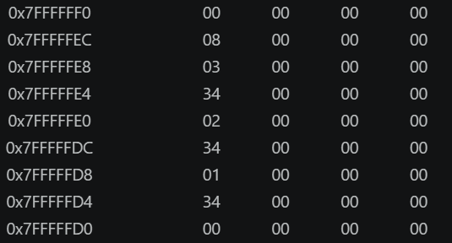

Final register values after considering input as 3 the x10 contains the output

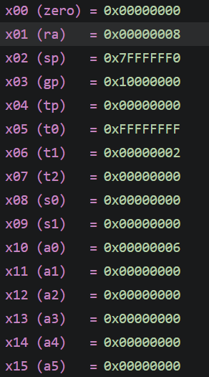
Part b
PC before and after fact function call:

PC before and after while loop implementation:
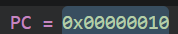
PC before and after exiting the loop

PC before and after returning from function

Stack:
There was no need to implement any stack as this function never call another function or itself, as it was a leaf function

Final register values after considering the input as 3, x10 register contains the results
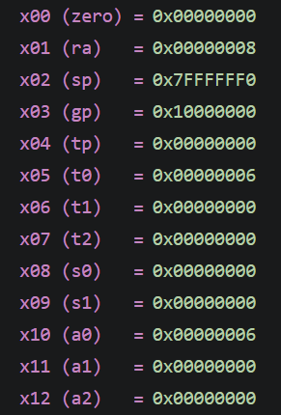

Comments

Part (a):
In the part a we used recursion to find the factorial that’s why we had to use implement stack which resulted in a greater number of instructions to be executed
Part (b):
In this part we used while loop to find the factorial that’s why we didn’t had to put our register values in the stack as it wasn’t calling any other function or itself

Task 2

Provide appropriately commented codes
.text
.globl main

main:
li x10, 3
li x7, 1
jal x1, fact # call fact(3)
j end # stop after return

fact:
addi sp , sp , -8 #adjust stack for 2 items
sw x1 , 4(sp) #save return address
sw x10 , 0(sp) #save argument n

addi x5 , x10 , -1 #x5 = n - 1
bge x5 , x7 , L1 #if (n - 1) >= 1, go to L1

addi x10 , x0 , 1 #return 0
addi sp , sp , 8 #pop stack
jalr x0 , 0(x1)

L1:
addi x10 , x10 , -1 #argument = n - 1
jal x1 , fact #recursive call

addi x6 , x10 , 0 #save result of fact(n-1)
lw x10 , 0(sp) #restore original n
lw x1 , 4(sp) #restore return address
addi sp , sp , 8 #pop stack

add x10 , x10 , x6 #n + fact(n-1)
jalr x0 , 0(x1) #return

end:
j end

Add screenshot of your results

The stack populated in first go and the sp value:

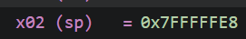
Stack populated in second go and the sp value:
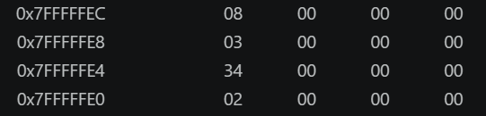
The stack populated in final go:
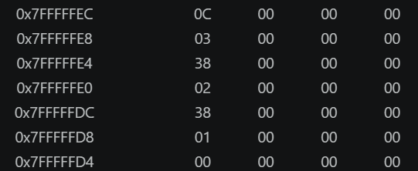
Final register values after assuming input as 3 and the final result is stored in x10
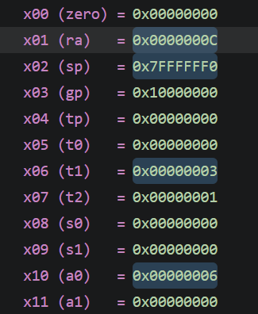

Comments
I just used the code provided in the task1(a) and just change the base case as it first was checking for if x5 was greater than or equal to 0 but now it check for greater than equal to 1 and then do recursion

Task 3

Provide appropriately commented codes
.text
.globl main

main:
li x10, 0x100
li x11, 4
li x5, 3
sw x5, 0(x10)
li x5, 1
sw x5, 4(x10)
li x5, 4
sw x5, 8(x10)
li x5, 2
sw x5, 12(x10)
jal x1, bubble
j end

bubble:
beq x10, x0, exit
beq x11, x0, exit

li x5, 0
loop_i:
bge x5, x11, exit
addi x6, x5, 0

loop_j:
bge x6, x11, next_i

slli x7, x5, 2
add x7, x10, x7
lw x28, 0(x7)

slli x29, x6, 2
add x29, x10, x29
lw x30, 0(x29)

bge x28, x30, skip
sw x30, 0(x7)
sw x28, 0(x29)

skip:
addi x6, x6, 1
j loop_j

next_i:
addi x5, x5, 1
j loop_i

exit:
jalr x0, 0(x1)

end:
j end

Add screenshots of your results
The unsorted array values
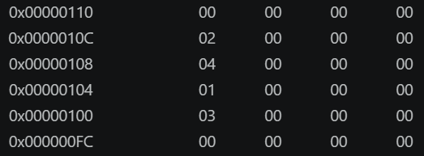
After first iteration of outer loop:
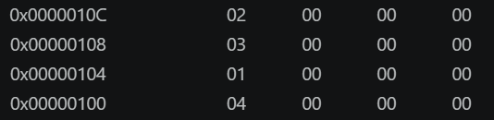
Final sorted array:
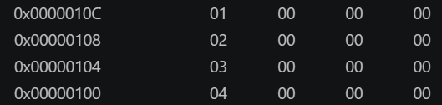

Final register values
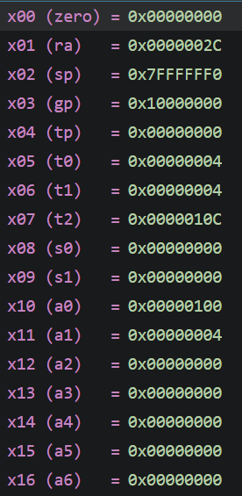
Comments:
In this code we used two nested loops to bubble sort and to avoid using the stack we used unconditional jumps without saving the return value, in order jump to the next iteration of loops via lables

Task 4

Provide appropriately commented codes
.text
.globl main

main:
li x10, 0x200
li x11, 5

li x5, 1 #array being populated
sw x5, 0(x10)
li x5, 2
sw x5, 4(x10)
li x5, 3
sw x5, 8(x10)
li x5, 4
sw x5, 12(x10)
li x5, 5
sw x5, 16(x10)

jal x1, sumOfSquares #call the func
j end

#
sumOfSquares:
addi sp, sp, -20 #saving value before the sceond function call
sw x1, 16(sp)
sw x8, 12(sp) # as x8, x9, x18 and x19 are saved register so to use them we gonna store their values
sw x9, 8(sp)
sw x18, 4(sp)
sw x19, 0(sp)

addi x8, x10, 0 # x8 = a
addi x9, x11, 0 # x9 = len
li x18, 0 # x18 = i = 0
li x19, 0 # x19 = sum = 0

loop:
bge x18, x9, done #if (i >= len) exit loop

slli x6, x18, 2 #x6 = i * 4
add x6, x8, x6 #x6 = address of a[i]
lw x10, 0(x6) #argument for square function

jal x1, square #call square function with argument in x10

add x19, x19, x10 #sum += sq (result returned in x10)
addi x18, x18, 1 #i++
j loop #repeat

done:
addi x10, x19, 0 #return value = sum

lw x1, 16(sp) #restore return address
lw x8, 12(sp) #restore s0
lw x9, 8(sp) #restore s1
lw x18, 4(sp) #restore s2
lw x19, 0(sp) #restore s3
addi sp, sp, 20

jalr x0, 0(x1) #return to caller

square:
mul x10, x10, x10 #return x * x
jalr x0, 0(x1) #return to caller

end:
j end

Add screenshots of your results
Saved register before function call:
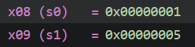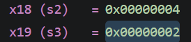
Saved registers stored in stack:
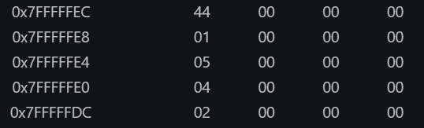
Saved register during and after function:
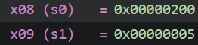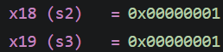

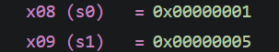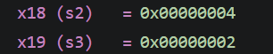
Final register values:
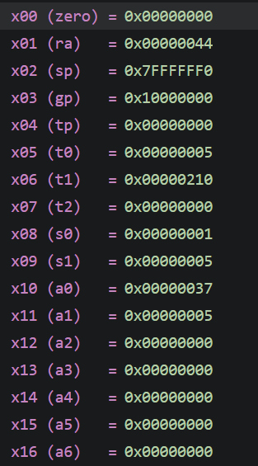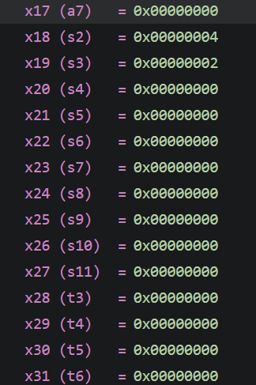
Comments:
This code first populates an array with elements 1,2,3,4,5 and save random values in x8,x9,x10,11 to demonstrate the stack implemented when we use these saved register in the function then in the main function it first save the saved registers values then it iterate ove the array and on each element it call another function square which gives a the square of that element which it then store in register x19 and the at the end it return the total sum from x19 into x10 and then it restores the values of all the saved registers back

Git hub repo link: https://github.com/M-Shees-Abbas/CA-labs.git

Lab 04 – Nest Procedures and Sorting

Assessment Rubrics

Points Distribution
Task No. | LR2  Code | LR 5  Results | AR 7  Report Submission & Github
Task 1 | /10 | /05 | /10 & /10
Task 2 | /10 | /10 | /10 & /10
Task 3 | /10 | /10 | /10 & /10
Task 4 | /15 | /10
Total Points | /100 Points
CLO Mapped | CLO 2
For description of different levels of the mapped rubrics, please refer the provided Lab Evaluation Assessment Rubrics and Affective Domain Assessment Rubrics.
# | Assessment Elements | Level 1: Unsatisfactory  Points 0-1 | Level 2: Developing  Points 2 | Level 3:Good  Points 3 | Level 4:Exemplary  Points 4
LR2 | Program/Code/ Simulation Model/ Network Model | Program/code/simulation model/network model does not implement the required functionality and has several errors. The student is not able to utilize even the basic tools of the software. | Program/code/simulation model/network model has some errors and does not produce completely accurate results. Student has limited command on the basic tools of the software. | Program/code/simulation model/network model gives correct output but not efficiently implemented or implemented by computationally complex routine. | Program/code/simulation /network model is efficiently implemented and gives correct output. Student has full command on the basic tools of the software.
LR5 | Results & Plots | Figures/ graphs / tables are not developed or are poorly constructed with erroneous results. Titles, captions, units are not mentioned. Data is presented in an obscure manner. | Figures, graphs and tables are drawn but contain errors. Titles, captions, units are not accurate. Data presentation is not too clear. | All figures, graphs, tables are correctly drawn but contain minor errors or some of the details are missing. | Figures / graphs / tables are correctly drawn and appropriate titles/captions and proper units are mentioned. Data presentation is systematic.
AR9 | Report | All the in-lab tasks are not included in report and / or the report is submitted too late. | Most of the tasks are included in report but are not well explained. All the necessary figures / plots are not included. Report is submitted after due date. | Good summary of most the in-lab tasks is included in report. The work is supported by figures and plots with explanations. The report is submitted timely. | Detailed summary of the in-lab tasks is provided. All tasks are included and explained well. Data is presented clearly including all the necessary figures, plots and tables.

